UNIVERSIDADE DO VALE DO ITAJAÍ
CAMPUS KOBRASOL – SÃO JOSÉ
CIÊNCIA DA COMPUTAÇÃO

Arquitetura de Computadores

Avaliação 01 – Programação em linguagem de montagem

Professor: Douglas Rossi de Melo
Aluno: Matheus Henrique Schaly

Data de entrega: 15/09/2017

C++ 1

// Disciplina: Arquitetura e Organização de Computadores
// Atividade: Avaliação 01 – Programação em C++
// Programa 01
// Grupo: - Matheus Henrique Schaly

#include <iostream>

using namespace std;

int main()
{
int vector1[8], vector2[8];
int numElementos;
while (true) {
cout << "Enter with array's size (max. = 8):\n";
cin >> numElementos;
if (numElementos > 0 && numElementos < 9) {
break;
}
cout << "Invalid value.\n";
}
for (int i = 0; i < numElementos; i++) {
cout << "Vector1[" << i << "] = ";
cin >> vector1[i];
}
for (int i = 0; i < numElementos; i++) {
cout << "Vector2[" << i << "] = ";
cin >> vector2[i];
}
int temp;
for (int i = 0; i < numElementos; i++) {
temp = vector1[i];
vector1[i] = vector2[i];
vector2[i] = temp;
}
cout << "\n";
for (int i = 0; i < numElementos; i++) {
cout << "Vetor1[" << i << "] = " << vector1[i] << "\n";
}
for (int i = 0; i < numElementos; i++) {
cout << "Vetor2[" << i << "] = " << vector2[i] << "\n";
}
}

Assembly MIPS 1

# Disciplina: Arquitetura e Organização de Computadores
# Atividade: Avaliação 01 – Programação em Linguagem de Montagem
# Programa 01
# Grupo: - Matheus Henrique Schaly

.data

#Creates RAM variables
vector1: .word 0, 0, 0, 0, 0, 0, 0, 0 #Inicializing vector 1
vector2: .word 0, 0, 0, 0, 0, 0, 0, 0 #Inicializing vector 2
mensagem1: .asciiz "Enter with array's size (max. = 8):\n" #Message prompting vectors size
mensagem2: .asciiz "Invalid value.\n" #Message warning invalid value
mensagem3: .asciiz "Vector1["
mensagem4: .asciiz "] = "
mensagem5: .asciiz "Vector2["
mensagem6: .asciiz "\n" #Jump line

.text

#Creates while's bounds
addi $t1, $zero, 0 #Store 0 at t1 (while's lower bound)
addi $t2, $zero, 9 #Store 9 at t2 (while's upper bound)

#Prompt arrays' size
while:
#Prints mensagem1
li $v0, 4 #Command to print a text
la $a0, mensagem1 #Load address of mensagem1 to a0
syscall #Do it

#Reads integer
li $v0, 5 #Read an integer and store it in v0
syscall #Do it

#Stores integer
move $t0, $v0 #Move to t0 (arrays' size) the integer in v0

#While's first if condition
bgt $t0 $t1 secondCondition #Branch to secondCondition if t0 (arrays' size) is greater than t1 (while's lower bound)

# Prints mensagem2
li $v0, 4 #Command to print a text
la $a0, mensagem2 #Load address of mensagem2 to a0
syscall #Do it

#Restarts while loop
j while #Jump to while

#While's second if condition
secondCondition:
blt $t0 $t2 exit #Branch to exit if t0 (arrays' size) is less than t2 (while's lower bound)

# Prints mensagem2
li $v0, 4 #Command to print a text
la $a0, mensagem2 #Load address of mensagem2 to a0
syscall #Do it

#Restarts while
j while #Jump to while
exit:

#Loads array1's base address
la $t2, vector1 #Load array1's base address to t2 (array1's base address)

#Loads array2's base address
la $t5, vector2 #Load array2's base address to t5 (array2's base address)

#Creates loop's index
addi $t1, $zero, 0 #Add zero and 0 and store it in t1 (loop's index)

#First for loop to gather array1's values
for1:
#Loop's if condition
beq $t1, $t0, for1Exit #Branch to for1Exit if t1 (loop's index) is equal to t0 (arrays' size)

#Prints mensagem3
li $v0, 4 #Command to print a text
la $a0, mensagem3 #Load address of mensagem3 to a0
syscall #Do it

#Prints index
li $v0, 1 #Command to print a integer
move $a0, $t1 #Move t1 (loop index) to a0
syscall #Do it

#Prints mensagem4
li $v0, 4 #Command to print a text
la $a0, mensagem4 #Load address of mensagem4 to a0
syscall #Do it

#Reads integer
li $v0, 5 #Read an integer and store it in v0 (it now has the input)
syscall #Do it

#Calculates the array1's addres to store the integer
sll $t3, $t1, 2 #Multiply t1 (loop's index) by 4 and put the result into t3 (bytes to be moved from array's base address)
add $t3, $t3, $t2 #Add t2 (array's base) and t3 (bytes to be moved from array's base address) and put it back into t3 (array's fully calculated address)

#Stores the input in array
sw $v0, ($t3) #Store word from v0 (that has the imput) in t3 (array's fully calculated address)

#Increases loop's index
addi $t1, $t1, 1 #Increase t1 (loop's index) by 1

#Restarts for loop
j for1 #Jump to for1

#Exits first for loop
for1Exit:

#Resets loop's index to 0
addi $t1, $zero, 0 #Add zero and 0 and store it in t1 (loop's index)

#Second for loop to gather array2's values
for2:
#Loop's if condition
beq $t1, $t0, for2Exit #Branch to for2Exit if t1 (loop's index) is equal to t0 (arrays' size)

#Prints mensagem3
li $v0, 4 #Command to print a text
la $a0, mensagem5 #Load address of mensagem3 to a0
syscall #Do it

#Prints index
li $v0, 1 #Command to print a integer
move $a0, $t1 #Move t1 (loop index) to a0
syscall #Do it

#Prints mensagem4
li $v0, 4 #Command to print a text
la $a0, mensagem4 #Load address of mensagem4 to a0
syscall #Do it

#Reads integer
li $v0, 5 #Read an integer and store it in v0 (it now has the input)
syscall #Do it

#Calculates the array2's addres to store the integer
sll $t3, $t1, 2 #Multiply t1 (loop's index) by 4 and put the result into t3 (bytes to be moved from array's base address)
add $t3, $t3, $t5 #Add t5 (array's base) and t3 (bytes to be moved from array's base address) and put it back into t3 (array's fully calculated address)

#Stores the input in array
sw $v0, ($t3) #Store word from v0 (that has the imput) in t3 (array's fully calculated address)

#Increases loop's index
addi $t1, $t1, 1 #Increase t1 (loop's index) by 1

#Restarts for loop
j for2 #Jump to for2

#Exits second for loop
for2Exit:

#Resets loop's index to 0
addi $t1, $zero, 0 #Add zero and 0 and store it in t1 (loop's index)

#Third for loop to swap arrays' values
for3:
#Loop's if condition
beq $t1, $t0, for3Exit #Branch to for3Exit if t1 (loop's index) is equal to t0 (arrays' size)

#Calculates the array1's addres to load an integer
sll $t3, $t1, 2 #Multiply t1 (loop's index) by 4 and put the result into t3 (bytes to be moved from array's base address)
add $t3, $t3, $t2 #Add t2 (array1's base) and t3 (bytes to be moved from array1's base address) and put it back into t3 (array1's fully calculated address)

#Loads the input from array1
lw $t4, ($t3) #Load word from t3 (array1's fully calculated address) to t4 (array1's value)

#Calculates the array2's addres to load an integer
sll $t6, $t1, 2 #Multiply t1 (loop's index) by 4 and put the result into t6 (bytes to be moved from array's base address)
add $t6, $t6, $t5 #Add t5 (array2's base) and t6 (bytes to be moved from array2's base address) and put it back into t6 (array2's fully calculated address)

#Loads the input from array2
lw $t7, ($t6) #Load word from t6 (array2's fully calculated address) to t7 (array2's value)

#Stores array1's value in array2's
sw $t4, ($t6) #Store word from t4 (array1's value) in t6 (array2's fully calculated address)

#Stores array2's value in array1's
sw $t7, ($t3) #Store word from t7 (array2's value) in t3 (array1's fully calculated address)

#Increases loop's index
addi $t1, $t1, 1 #Increase t1 (loop's index) by 1

#Restarts for loop
j for3 #Jump to for3

#Exits third for loop
for3Exit:

#Prints mensagem6
li $v0, 4 #Command to print a text
la $a0, mensagem6 #Load address of mensagem6 to a0
syscall #Do it

#Resets loop's index to 0
addi $t1, $zero, 0 #Add zero and 0 and store it in t1 (loop's index)

#Forth for loop to print array1's values
for4:
#Loop's if condition
beq $t1, $t0, for4Exit #Branch to for4Exit if t1 (loop's index) is equal to t0 (arrays' size)

#Prints mensagem3
li $v0, 4 #Command to print a text
la $a0, mensagem3 #Load address of mensagem3 to a0
syscall #Do it

#Prints index
li $v0, 1 #Command to print a integer
move $a0, $t1 #Move $t1 (loop index) to a0
syscall #Do it

#Prints mensagem4
li $v0, 4 #Command to print a text
la $a0, mensagem4 #Load address of mensagem4 to a0
syscall #Do it

#Calculates the array1's addres to load an integer
sll $t3, $t1, 2 #Multiply t1 (loop's index) by 4 and put the result into t3 (bytes to be moved from array's base address)
add $t3, $t3, $t2 #Add t2 (array1's base) and t3 (bytes to be moved from array's base address) and put it back into t3 (array's fully calculated address)

#Loads the input from array1
lw $t4, ($t3) #Load word from t3 (array1's fully calculated address) to t4 (array1's value)

#Prints array1 at index t1
li $v0, 1 #Command to print a integer
move $a0, $t4 #Move t4 (the value) to a0
syscall #Do it

#Prints mensagem6
li $v0, 4 #Command to print a text
la $a0, mensagem6 #Load address of mensagem6 to a0
syscall #Do it

#Increases loop's index
addi $t1, $t1, 1 #Increase t1 (loop's index) by 1

#Restarts for loop
j for4 #Jump to for4

#Exits forth for loop
for4Exit:

#Resets loop's index to 0
addi $t1, $zero, 0 #Add zero and 0 and store it in t1 (loop's index)

#Fifth for loop to print array2's values
for5:
#Loop's if condition
beq $t1, $t0, for5Exit #Branch to for5Exit if t1 (loop's index) is equal to t0 (arrays' size)

#Prints mensagem3
li $v0, 4 #Command to print a text
la $a0, mensagem5 #Load address of mensagem5 to a0
syscall #Do it

#Prints index
li $v0, 1 #Command to print a integer
move $a0, $t1 #Move $t1 (loop index) to a0
syscall #Do it

#Prints mensagem4
li $v0, 4 #Command to print a text
la $a0, mensagem4 #Load address of mensagem4 to a0
syscall #Do it

#Calculates the array2's addres to load an integer
sll $t3, $t1, 2 #Multiply t1 (loop's index) by 4 and put the result into t3 (bytes to be moved from array's base address)
add $t3, $t3, $t5 #Add t5 (array2's base) and t3 (bytes to be moved from array's base address) and put it back into t3 (array's fully calculated address)

#Loads the input from array2
lw $t4, ($t3) #Load word from t3 (array1's fully calculated address) to t4 (array1's value)

#Prints array2 at index t1
li $v0, 1 #Command to print a integer
move $a0, $t4 #Move t4 (the value) to a0
syscall #Do it

#Prints mensagem6
li $v0, 4 #Command to print a text
la $a0, mensagem6 #Load address of mensagem6 to a0
syscall #Do it

#Increases loop's index
addi $t1, $t1, 1 #Increase t1 (loop's index) by 1

#Restarts for loop
j for5 #Jump to for5

#Exits fifth for loop
for5Exit:

Capturas de Tela 1:

Pergunta o tamanho do vetor:
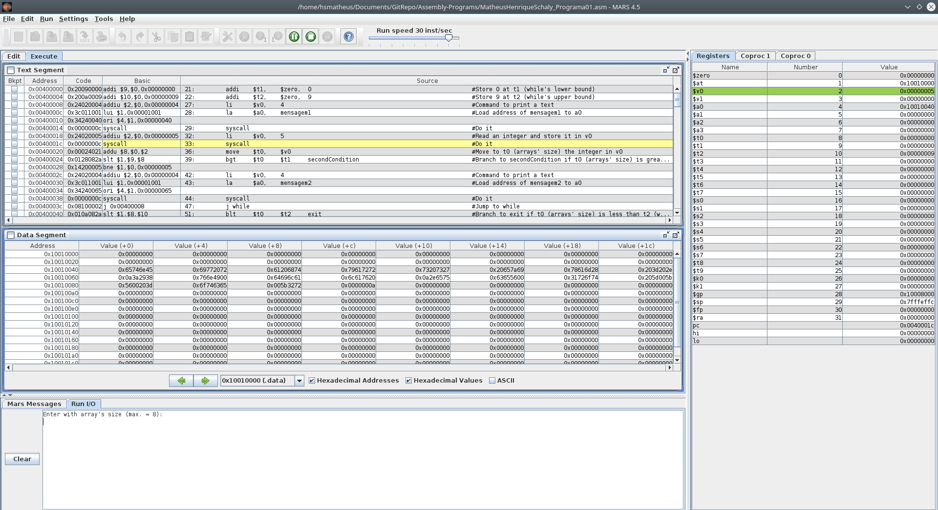
Possíveis valores inválidos:
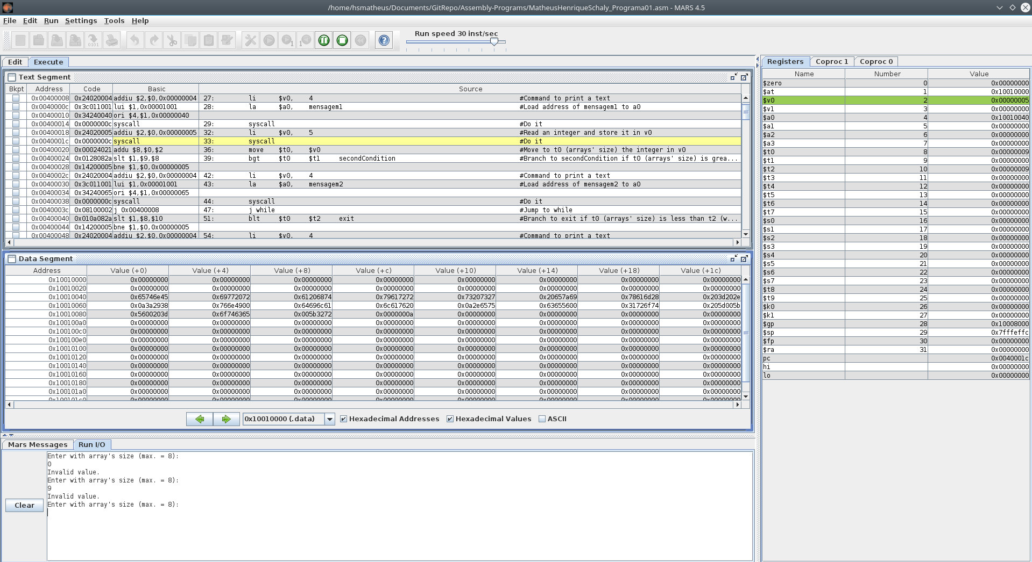
Entrada de um valor correto:
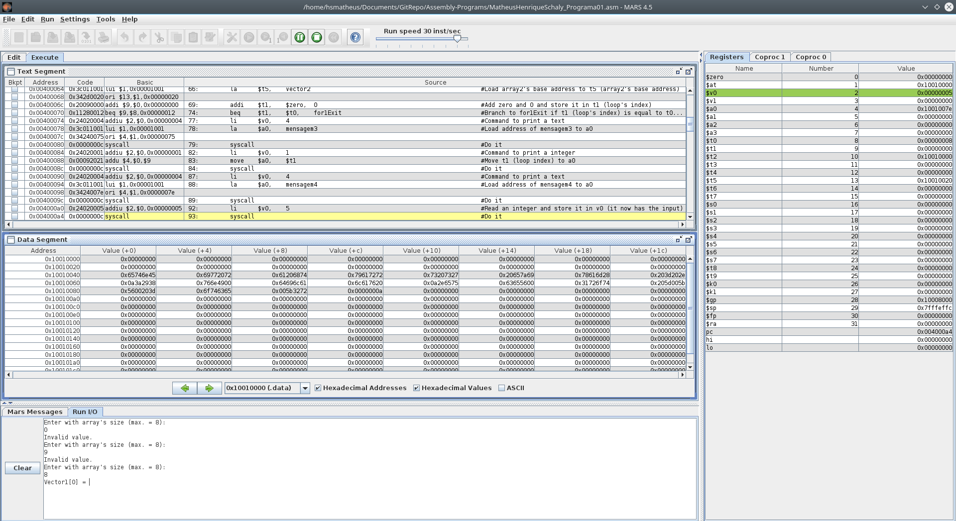
Entrada de valores no vetor1:
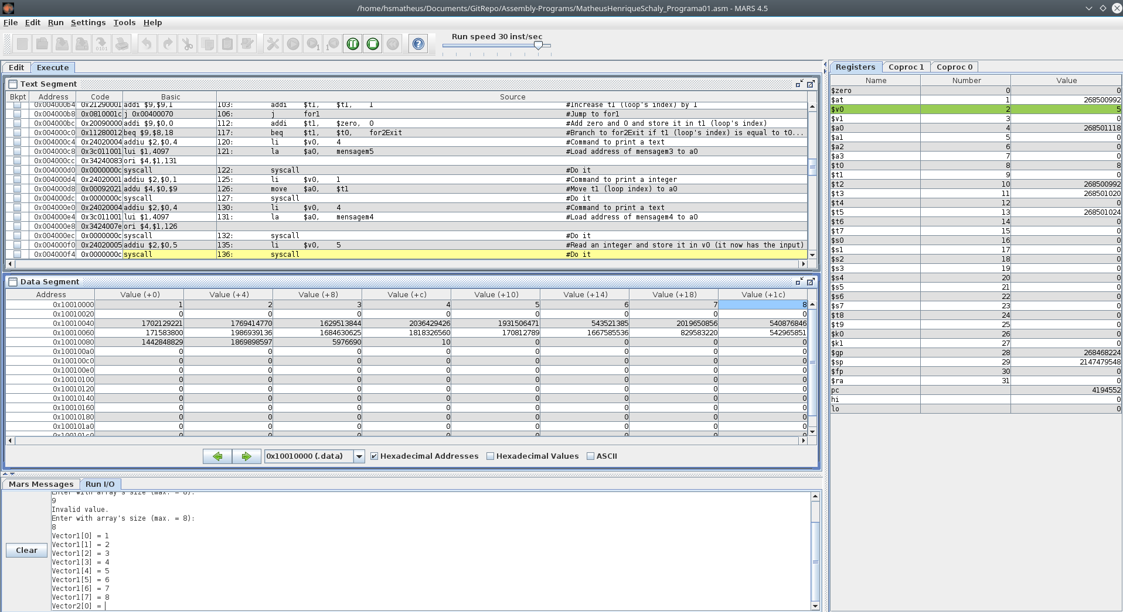

Entrada de valores no vetor2:
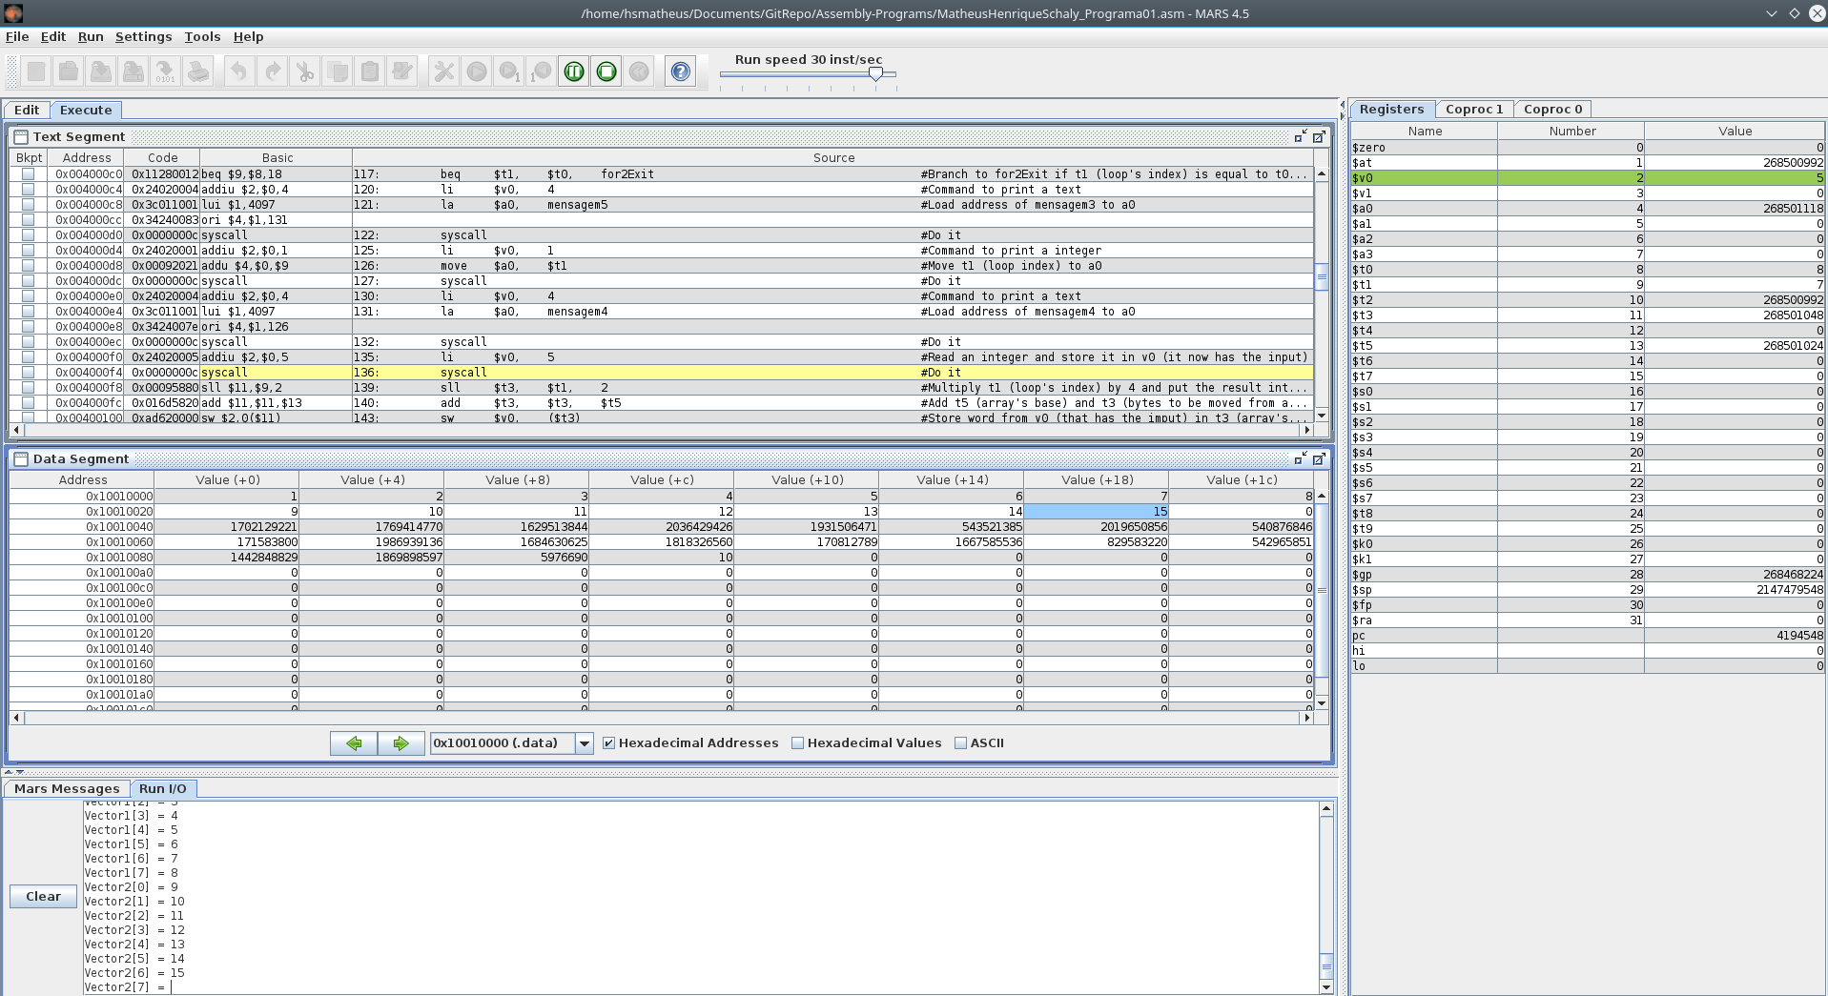
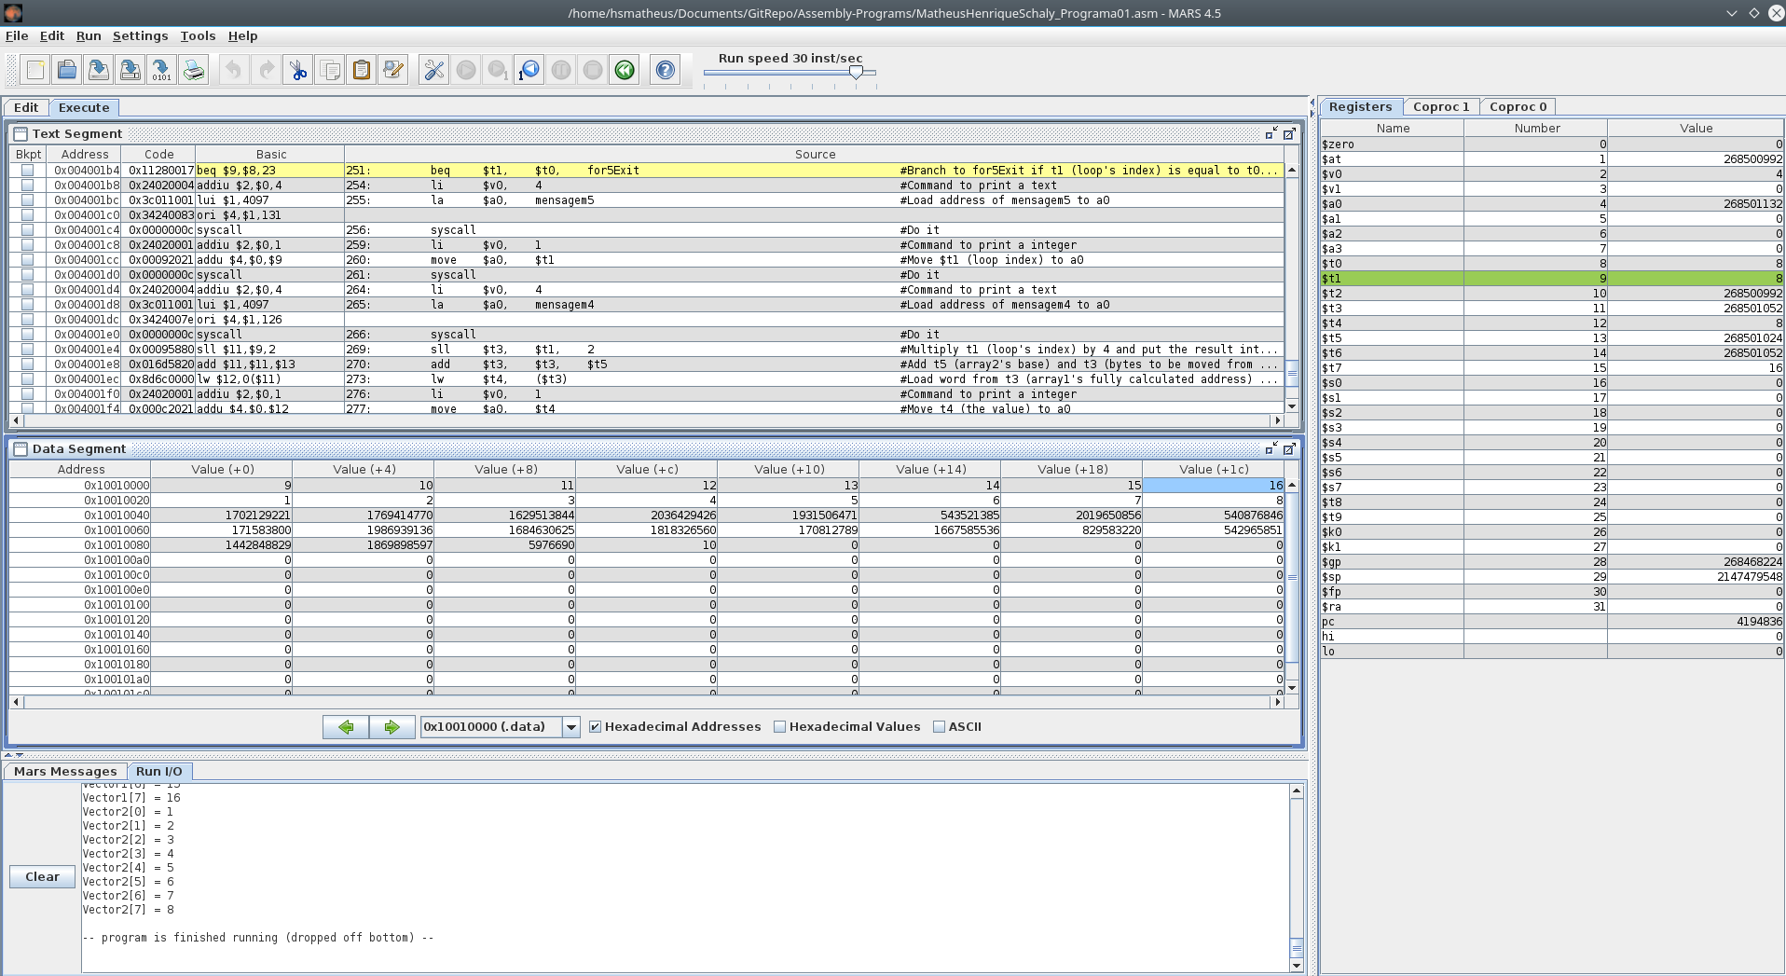
Resultado final, com valores já trocados:

Quadro de análise das instruções:
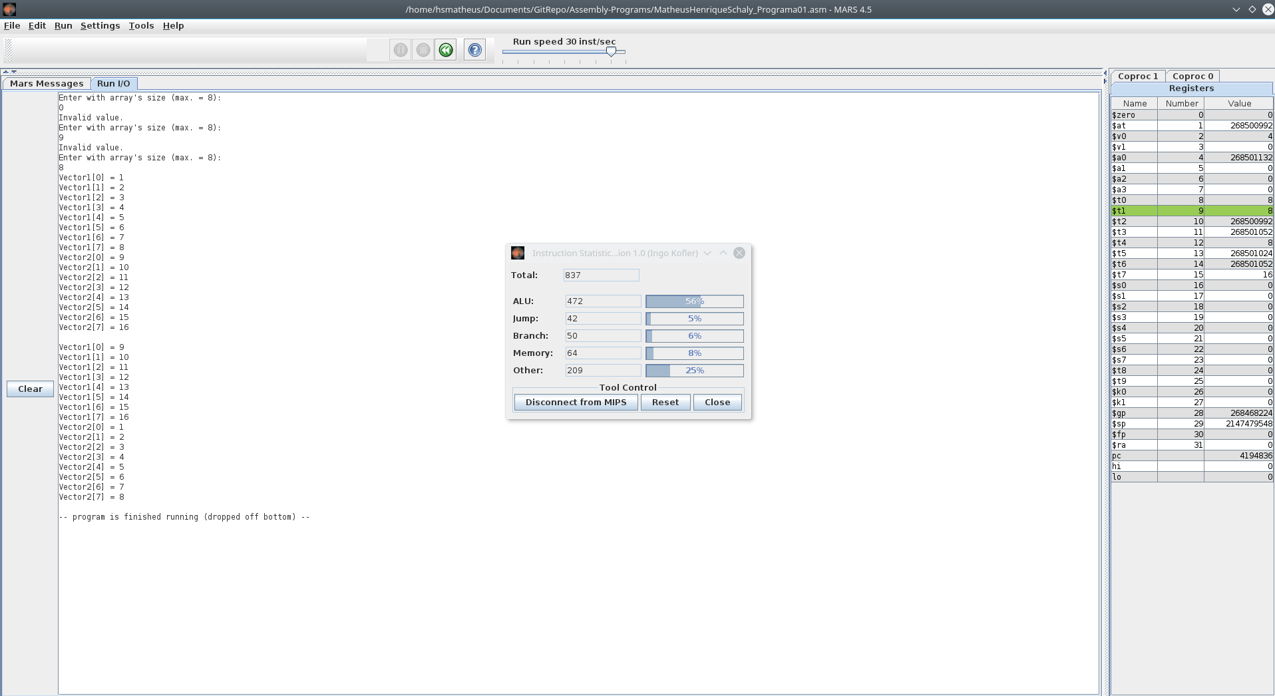

C++ 2

// Disciplina: Arquitetura e Organização de Computadores
// Atividade: Avaliação 01 – Programação em C++
// Programa 02
// Grupo: - Matheus Henrique Schaly

#include <iostream>
#include <algorithm>

using namespace std;

int main()
{
int record[16][32], student, myClass, presence;

for (int i = 0; i < 16; i++) {
for (int j = 0; j < 32; j++) {
record[i][j] = 1;
}
}

while (true) {
do {
cout << "Enter class' number (0 to 15): ";
cin >> myClass;
} while (myClass < 0 || myClass > 15);
do {
cout << "Enter student's number (0 to 31): ";
cin >> student;
} while (student < 0 || student > 31);
do {
cout << "Enter register's type (presence = 1; absence = 0): ";
cin >> presence;
} while (presence < 0 || presence > 1);
record[myClass][student] = presence;
}
}

Assembly MIPS 2

# Disciplina: Arquitetura e Organização de Computadores
# Atividade: Avaliação 01 – Programação em Linguagem de Montagem
# Programa 02
# Grupo: - Matheus Henrique Schaly

#Data stored in RAM
.data
#Creates RAM variables
message1: .asciiz "Enter class' number (0 to 15): "
message2: .asciiz "Enter student's number (0 to 31): "
message3: .asciiz "Enter register's type (presence = 1; absence = 0): "
message4: .asciiz "Changed vector's word:\n"
message5: .asciiz "\n\n"
presenceVector: .word 0xFFFFFFFF, 0xFFFFFFFF, 0xFFFFFFFF, 0xFFFFFFFF, 0xFFFFFFFF, 0xFFFFFFFF, 0xFFFFFFFF, 0xFFFFFFFF, 0xFFFFFFFF, 0xFFFFFFFF, 0xFFFFFFFF, 0xFFFFFFFF, 0xFFFFFFFF, 0xFFFFFFFF, 0xFFFFFFFF, 0xFFFFFFFF #Create a vector with 16 elements, each of them has 32 bits, that are all set to 1
mask: .word 1 #Mask with 32 bits, with only its last bit set to 1

.text

#Loads array1's base address
la $t3, presenceVector #Load presenceVector's base address to t3 (presenceVector's base address)

#Creates while's lower bound
addi $t6, $zero, 0 #Store 0 at t6 (while's lower bound)

#Inifinite loop
start:

#Creates/Resets while's upper bound
addi $t7, $zero, 15 #Store 15 at t7 (while's upper bound)

#Do while loop to get class' number
getClass:

#Prints a text
li $v0, 4 #Command to print a text
la $a0, message1 #Load address of mensagem1 to a0
syscall #Do it

#Reads integer
li $v0, 5 #Read an integer and store it in v0
syscall

#Stores integer
move $t0, $v0 #Move to t0 (class' number) the integer in v0

#While's first if condition
bge $t0 $t6 secondCondition1 #Branch to secondCondition if t0 (class' number) is greater than or equal t6 (while's lower bound)
j getClass #Jump to getClass

#While's second if condition
secondCondition1:
ble $t0 $t7 getClassExit #Branch to exit if t0 (class' number) is less than or equal t7 (while's upper bound)
j getClass

getClassExit:

#Readjusts while's upper bound
addi $t7, $zero, 31 #Store 31 at t7 (while's upper bound)

#Do while loop to get student's number
getStudent:

#Prints a text
li $v0, 4 #Command to print a text
la $a0, message2 #Load address of mensagem2 to a0
syscall #Do it

#Reads integer
li $v0, 5 #Read an integer and store it in v0
syscall #Do it

#Stores integer
move $t1, $v0 #Move to t1 (student's number) the integer in v0

#While's first if condition
bge $t1, $t6 secondCondition2 #Branch to secondCondition if t1 (student's number) is greater than or equal t6 (while's lower bound)
j getStudent #Jump to getStudent

#While's second if condition
secondCondition2:
ble $t1, $t7 getStudentExit #Branch to exit if t1 (student's number) is less than or equal t7 (while's upper bound)
j getStudent

getStudentExit:

#Readjusts while's upper bound
addi $t7, $zero, 1 #Store 31 at t7 (while's upper bound)

#Do while loop to get student's presence
getPresence:

#Prints a text
li $v0, 4 #Command to print a text
la $a0, message3 #Load address of mensagem3 to a0
syscall #Do it

#Reads integer
li $v0, 5 #Read an integer and store it in v0
syscall

#Stores integer
move $t2, $v0 #Move to t2 (student's presence) the integer in v0

#While's first if condition
bge $t2, $t6 secondCondition3 #Branch to secondCondition if t2 (student's presence) is greater than or equal t6 (while's lower bound)
j getPresence #Jump to getPresence

#While's second if condition
secondCondition3:
ble $t2, $t7 getPresenceExit #Branch to exit if t2 (student's presence) is less than or equal t7 (while's upper bound)
j getPresence

getPresenceExit:

#A - Calculates the presenceVector's address to be changed
sll $t4, $t0, 2 #Multiply t0 (class' number) by 4 and put the result into t4 (bytes to be moved from presenceVector's base address)
add $t4, $t4, $t3 #Add t3 (presenceVector's base) and t4 (bytes to be moved from presenceVector's base address) and put it back into t4 (presenceVector's fully calculated address)

#Loads the input from presenceVector
lw $t5, ($t4) #Load word from t4 (presenceVector's fully calculated address) to t5 (presenceVector's value)

#B - Calculates how many mask's bits will be moved
lw $t7, mask #Load address of mask to t7 (original mask)
sllv $t7, $t7, $t1 #Multiply t7 (original mask) by t1 (student's number) and put the result into t7 (mask bits moved for t1 times)

#C - If condition to check if student is or not present
beq $t2, $t6, registerAusence #Branch to registerAusence if t2 (student's presence) is equal to t6 (while's lower bound (which is 0))

#Register a presence

#OR mask and presenceVector's single position
or $t5, $t5, $t7 #OR t7 (changed mask) and t5 (presenceVector's value) then put the result into t5 (presenceVector's changed value)

#Stores presenceVector's changed value back
sw $t5, ($t4) #Store word from t5 (presenceVector's changed value) in t4 (presenceVector's fully calculated address)

#Restarts the whole loop
j print #Jump to start

#Register a ausence
registerAusence:

#XOR mask and 32 bits (all set to 1)
xori $t7, $t7, 0xFFFFFFFF #XOR (exclusive OR) t7 (changed mask) and 32 bits (all set to 1) then put the result into t7 (XORed mask)

#AND XORed mask and presenceVector's single position
and $t5, $t7, $t5 #OR t7 (XORed mask) and t5 (presenceVector's value) then put the result into t5 (presenceVector's changed value)

#Stores presenceVector's changed value back
sw $t5, ($t4) #Store word from t5 (presenceVector's changed value) in t4 (presenceVector's fully calculated address)

#Prints the value that has returned to presenceVector and new lines
print:

#Prints mensagem4
li $v0, 4 #Command to print a text
la $a0, message4 #Load address of message4 to a0
syscall #Do it

#Prints the value that has returned to presenceVector
la $v0, 35 #Command to print a integer as binary
la $a0, ($t5) #Load word of t5 (presenceVector's value) to a0
syscall #Do it

#Prints mensagem5
li $v0, 4 #Command to print a text
la $a0, message5 #Load address of message5 to a0
syscall #Do it

#Restarts the whole loop
j start #Jump to start

Capturas de Tela 2:

Inicializando programa:
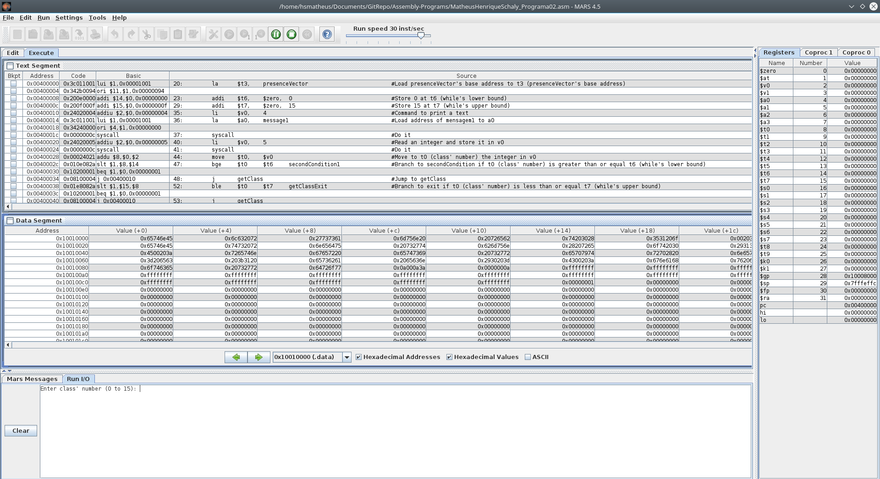

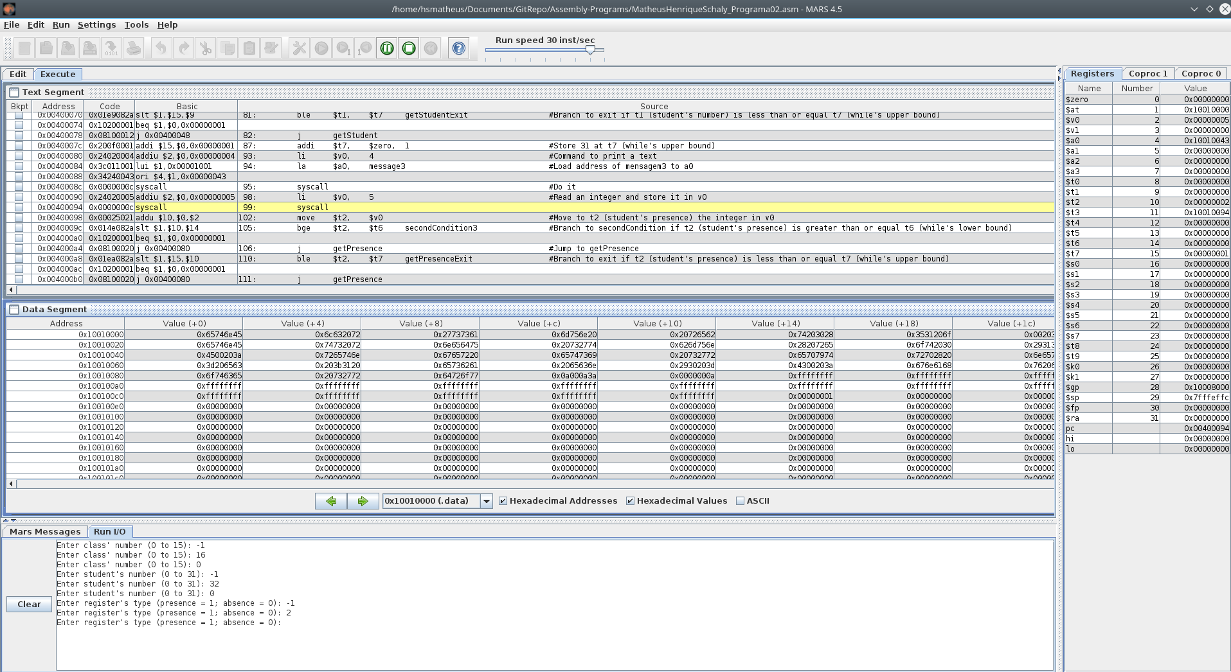
Possíveis valores inválidos e em seguida entrada correta:
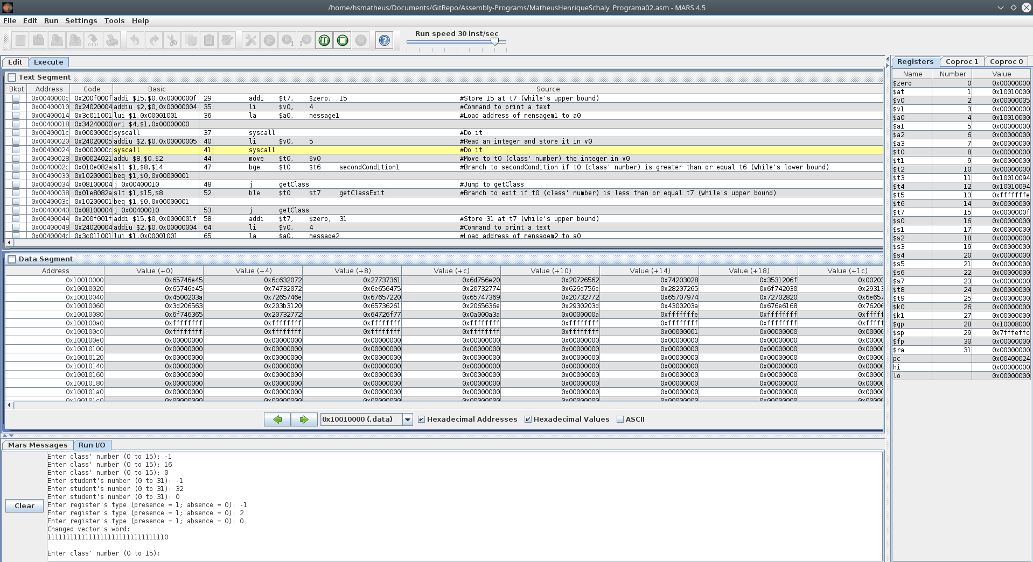
Após entrada de valores, o valor da coluna Value(+14) e linha 0x10010080 (que simboliza o primeiro elemento do vetor) passa de 0xffffffff para 0xfffffffe, ou seja, um de seus bits foi alterado. Neste caso o primeiro bit (índice 0) foi alterado, como é demonstrado mais explicitamente na saída do programa, onde o primeiro bit (índice 0) passa de 1 para 0:

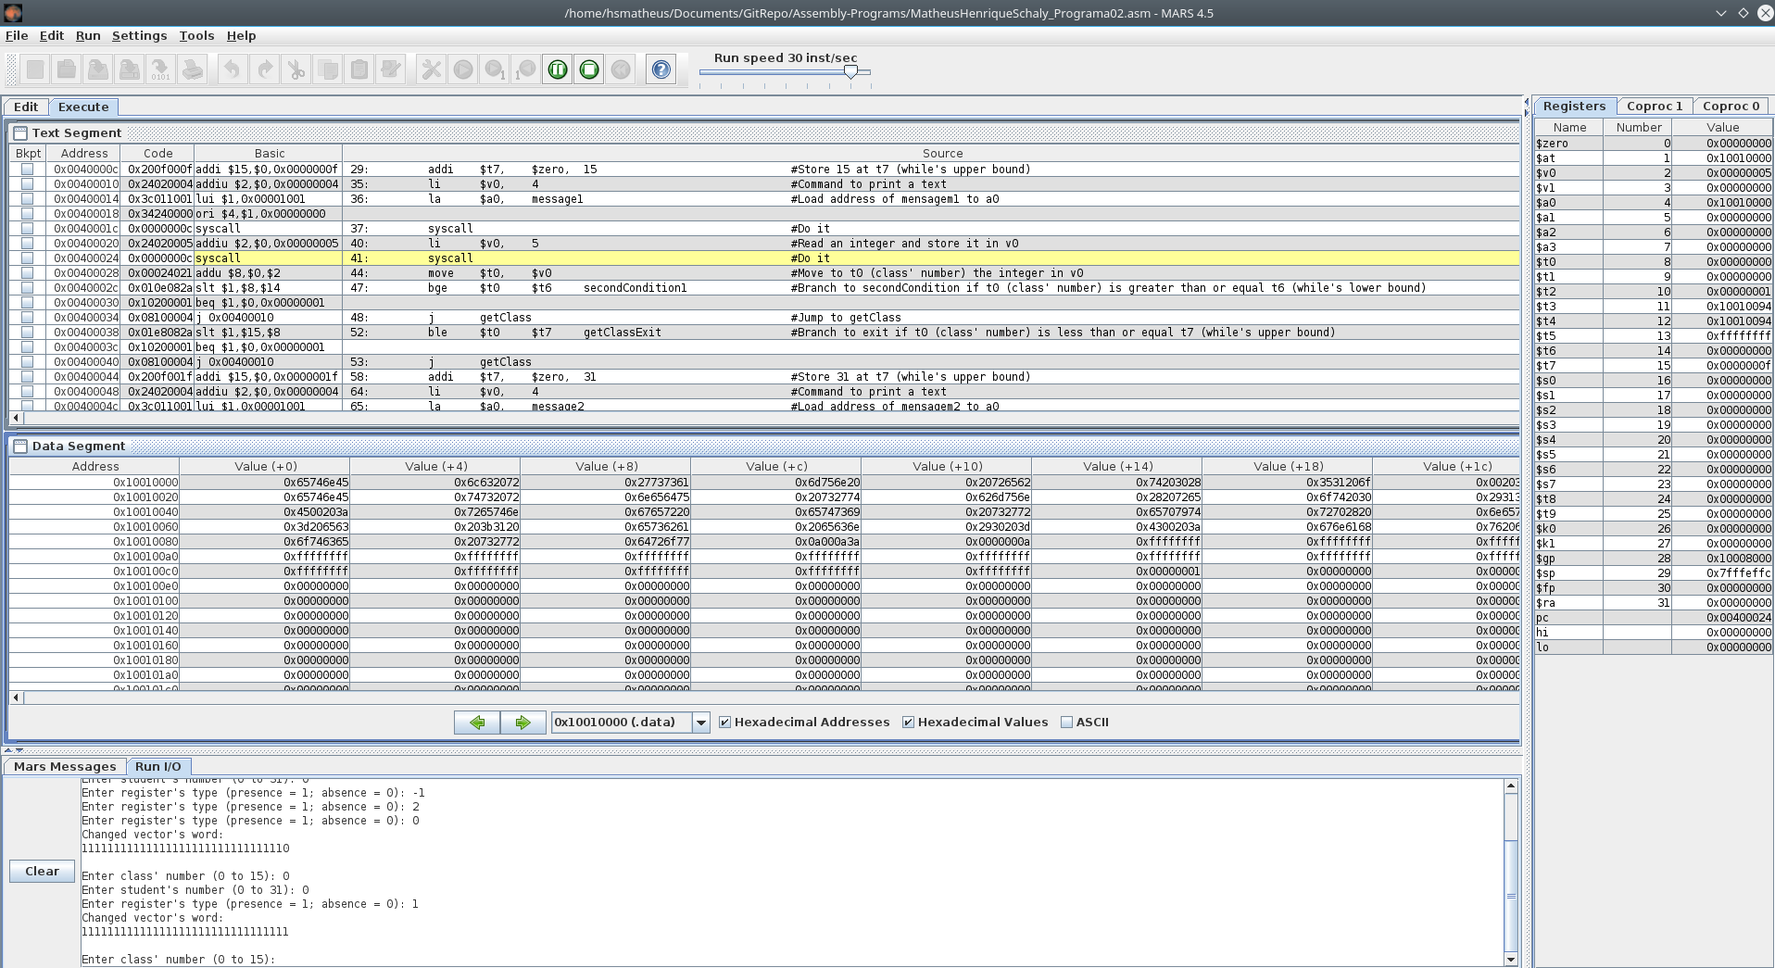
Retornando o valor do primeiro elemento do vetor para 0xffffffff, acompanhado pela demonstração binária na saída do programa:

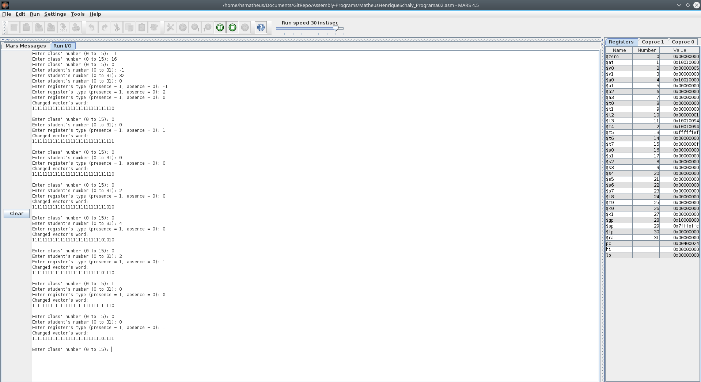
Exemplos do programa em execução:

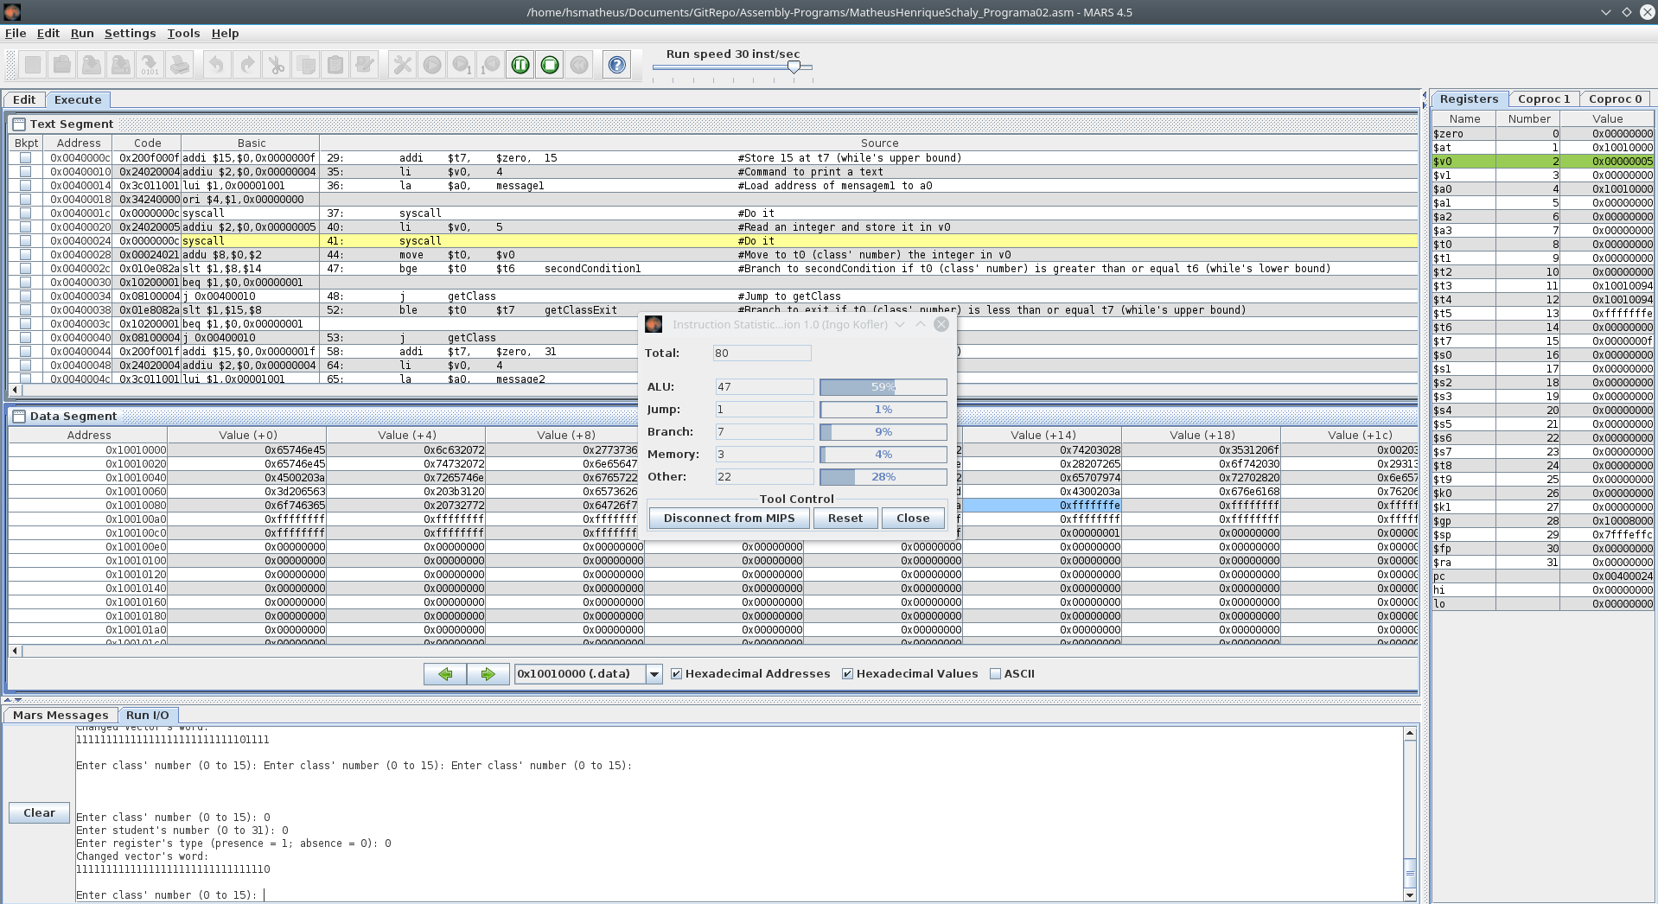
Quadro de análise das instruções (apenas um loop):

